Closing The Loop
Towards A Low-Cost “LAN” (Learning through Authentic Narrative) Infrastructure for Community and Cross-Cultural Empowerment

(Track: Educational Reform, Policy and Innovation)

Ian H. Frank*, Malcolm H. Field†, Dominic Bagenda†, Ken-ichi Shiiya‡
*Department of Complex and Intelligent Systems, Future University Hakodate
†Department of Media Architecture, Future University Hakodate/‡Freelance Consultant
{ianf, marukomu, bagenda}@fun.ac.jp, footloose0401@yahoo.co.jp

Abstract: We present an unconventional “whole system” approach to Open Educational Resources (OERs). Whereas a significant proportion of existing OER content creation can be categorised as “top-down”, we advocate a perspective that privileges the bottom-up “closing of the loop”: enabling the creation of meaningful content across different layers within an education system, and also across cultures. Central to this approach is the framing of educational materials as authentic narratives. We present a framework for implementing this “LAN” (Learning through Authentic Narrative) approach, and instantiate it with concrete examples from our own fieldwork that illustrate the separate stages of content creation, content distribution, and content management. We simultaneously target both developed and developing countries, and we demonstrate the potential for both within-community and cross-cultural empowerment.

Introduction
The screen captures below show two stills from videos on hygiene made by Japanese university students for an audience of Ugandan primary age children (Fig. 1). The Japanese students were given appropriate cultural background when creating their narratives, and the videos were used by Ugandan students in a trial carried out by the third author. This paper is about our work on a framework that can foster and promote this kind of “Learning through Authentic Narrative” (LAN) approach both within and across cultures.

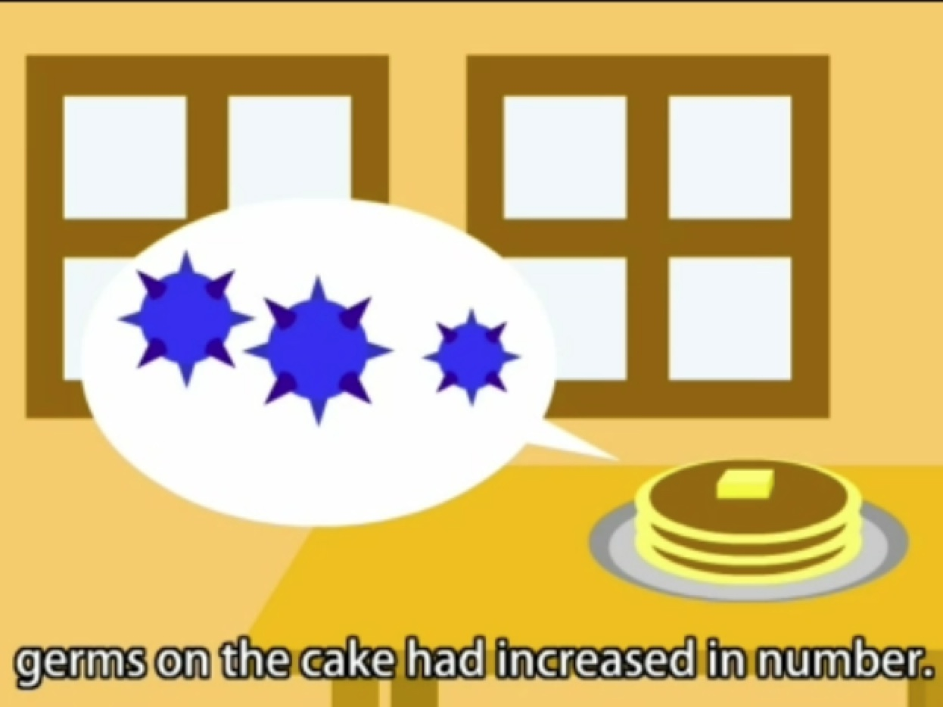
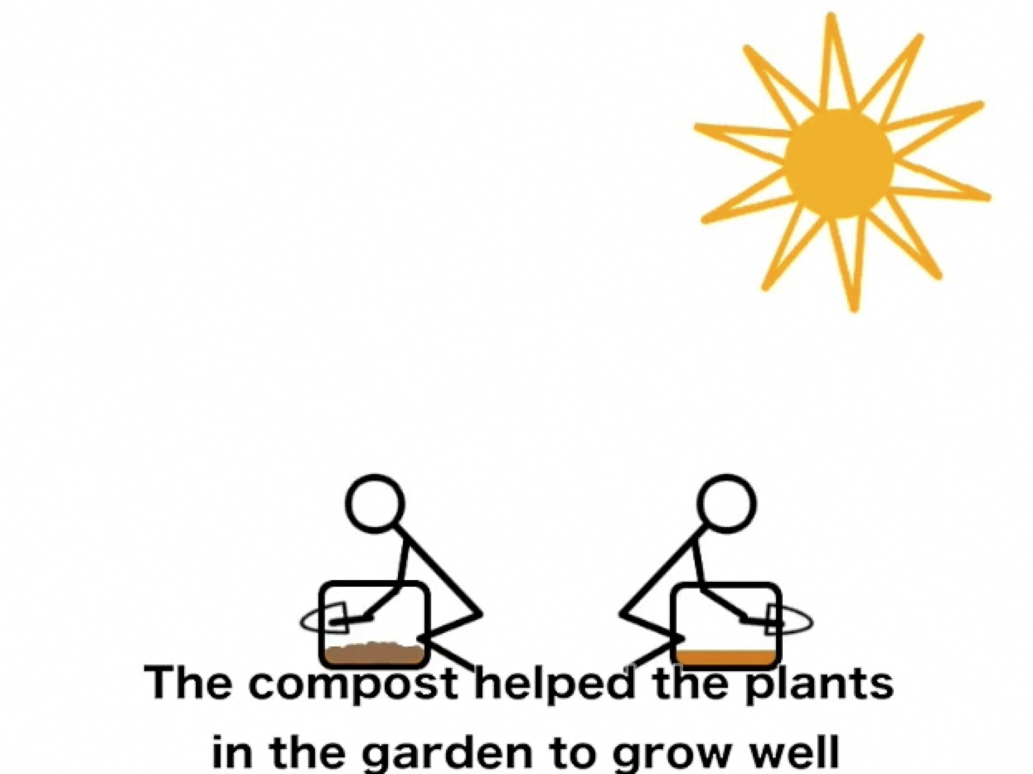
Figure 1: Two screenshots of “hygiene” narratives

In the following section we give further motivation for our approach, as well as presenting the overall framework. We then make a detailed review of the context of our work, which includes Open Educational Resources (OERs) in general, and also motivation from a perspective on the status of science education. We then give more examples from our fieldwork that demonstrate the breadth and potential of our approach, before concluding by signposting directions for future research and application.
Motivation and the LAN Framework
The impetus for this work was a belief that authentic, narrative stories (of needs, experiences, dreams, and understanding) could be a bridgehead in the endeavour to create and share knowledge. It is not controversial to believe that stories told by the members of communities can empower individuals by changing behaviour: particularly, narratives are much employed to impart identity and thinking from generation to generation. However, the effective and wide-scale dissemination of “knowledge” in this way within formal education is not mainstream. This paper represents a distillation of our work on making a new thoroughfare for narratives: a “LAN” infrastructure that can connect and cross communities.

There are many reasons why narrative-based approaches may not complement the learning structures of existing educational systems, including the scarcity of resources, the linear structure of much course design, and gaps in the skills needed to successfully augment curricula using technology-based approaches. When contemplating utilising the power of story, it is therefore necessary to identify flexible approaches that can be adapted to easily fit many proclivities and environments.

We have been exploring the possibilities for broadly impacting mindsets in this way through a notion of “Learning through Authentic Narrative” (hereafter, LAN). We believe that an extremely straightforward framework can be created around some extremely simple technology that can allow all ages and nationalities to very simply create and share short stories. If these stories are about educational issues (such as hygiene), learning can result.

The basic steps in our LAN framework are:

- Content creation: provision to allow stories to be created (at the simplest level, with pen and paper, ideally in a digital movie format).

- Content creators: we believe that those higher in an education chain, such as university students or indigenous experts (either experts working within a country/community, or expatriate experts) are ideal as the primary creators of narratives. Filtering content down through an education system or community in this way can “close the loop” of meeting needs in context, and of local empowerment. We also see great educational potential in the cross-cultural learning that can result from creating analog (for example, textual) narratives in one culture, and then digitising the narratives in another country or context.

- Narrative content: we set the primary target for narrative content as the existing curricula of a country's/community's education system.

- Context: by making it possible for individuals and communities to make stories that include aspects of their own experiences or hopes or dreams, we can maximise the opportunity for creating “authentic” narrative and a genuine voice.

- Content distribution: LAN educational resources are “online” to the extent that we can create distribution networks for them. In developed countries, infrastructure can be created relatively easily by employing readily available Internet resources such as YouTube. For the Developing South we propose a novel and extremely low-cost system based on “iBikes”.

- Content management: This final area of our framework will be developed as we build more educational materials. We envisage a system with SNS features that allows popular videos to rise to the surface, and separation of content viewing and review data based on region. Any management system will also have to work in “batch mode” to cope with iBike units returning en masse from extended deployments in areas with no Internet connectivity.

The content creation concept for this framework resulted from previous work by the first two authors on an agenda of reducing classroom technology in order to concentrate on developing thinking skills (Frank & Field, 2008). We have raised the question of whether the economists' “resource curse” paradox applies to education: despite the many claims that technology improves learning and classroom practices, the perception of student abilities is not one of the same startling progress (Frank & Field 2010). Our work led us to the Scratch programming language developed by the Lifelong Kindergarten Group (http://llk.media.mit.edu/) at MIT Media Lab. Scratch was specifically aimed at young children, and therefore met our desire to maximally simplify a class environment while still implicitly allowing us to challenge students’ science, maths and technological thinking in skills such as programming and communication. Scratch provided a good entry point that enabled students to develop technological skills (such as programming, design and interface), and to demonstrate their knowledge of content areas (maths and science). This work in turn led us to Stop Action Motion (SAM) animation (www.samanimation.com), which can produce animations from pictures taken by a bottom-of-the line digital camera (only 640x480 pixel resolution is necessary). This software allowed even more freedom than Scratch, and narrowed the focus to just the storytelling/narrative aspects. It is with software such as Scratch and SAM that we intend to facilitate the LAN creation of content within communities. We already have experience of using this software in workshops with educators (see “Further Examples” section), and we believe that with minimal instruction it is possible for teachers, and students at the higher levels of an education system, to generate video content.

Our goal is to establish what Paul Kim (2010) has coined “contextualized innovations” that can overcome sustainability challenges by virtue of being generated locally in a way appropriate to the learning environment. As Oliver (2002) and Ayoo (2010) have reiterated, opportunities made available through technologically-facilitated learning require changing the role of the teacher to include a pool of other experts who participate in the development of resources. Traditionally, it has not been possible to include the majority of learners in the “pooling of resources” due to economics, fixed facilities and rigid scheduling. Our recent collaborations with NGO personnel and institutions (domestic and international, see Further Examples section) have indicated that learners can develop relevant contextual resources that are mobile across physical and digital platforms through developing digital-narratives around a content area.

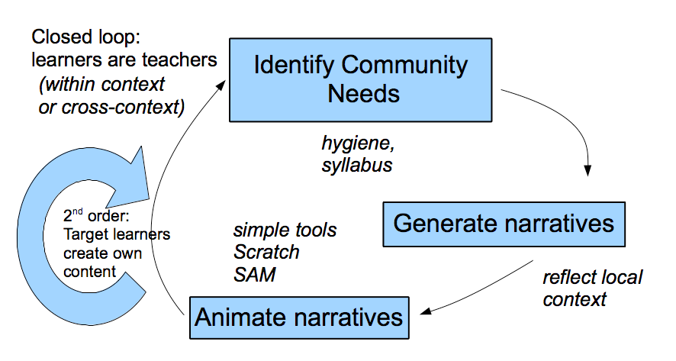
The process is illustrated schematically below (Fig. 2). First, community needs must be identified (in the example stills from the Introduction, the needs were based on hygiene, but there are many other possibilities). With subject matter decided, candidate stories can be generated, preferably bearing a relation to the cultural context. These stories can then be transformed into digital narratives, for which straightforward software, such as Scratch and SAM, is indispensable. We believe that learners should be involved in at least one of the three stages (especially the final two), and that it is “closing the loop” to make learners teachers in this way that gives the framework the potential to create a living system supporting education. The loop may cross cultures, as with our Japanese-Ugandan examples from the Introduction, or may be contained within a single education environment. There is further potential for “epicylces”, or second order loops, in which target learners themselves (for instance, elementary school students) create stories or digital narratives about the content they have learned, giving an opportunity to both feed further content into the loop, and to gauge the quality of the learning taking place.

Figure 2: Closing the loop in content creation

Since our project is still in its first eighteen months, the content distribution and content management portions of the framework are comparatively less fully developed. However, for communities with existing technological resources, we have used videos loaded onto iPads and have created a nascent Internet distribution channel (http://www.youtube.com/user/LIFELAN) similar in concept to that of the Khan Academy (http://www.khanacademy.org). We base our Internet distribution of materials on a YouTube channel for its provision of straightforward APIs that can support future interface development.

Our goal is to impact education over the broadest possible spectrum of resource availability, and we believe that mobile devices with pre-loaded content are not incompatible with deployment in areas with little electricity or connectivity: for instance, our trial in Uganda used iPad units (see Fig. 3). For such Developing South countries we are considering an extremely low cost solution that involves transporting a dozen or so iPads on bicycles or motorbikes, which we call “iBikes”. To be effective, such a system would need to be accompanied by on-the-ground support and teacher education, and we would use the fourth author's 26 months' experience of teaching at Ugandan PTCs (Primary Teachers Colleges) to increase the chances of acceptance of deployments. Our expectation is that small-scale field successes will help identify improved technology matches, and may even have the potential to drive the direction of technological innovation, by articulating hitherto poorly publicised needs.

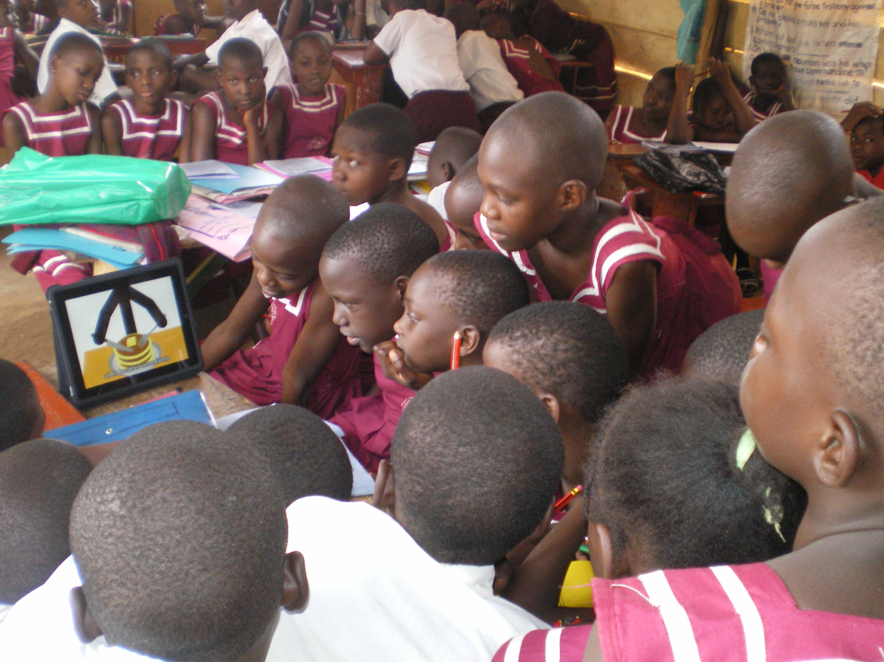
Figure 3: An iPad unit with LAN content in a Ugandan elementary school

Content management support systems are not our main focus at this stage of the research, but we believe that once significant content is being viewed online or on mobile units, we will have interesting opportunities for developing original algorithms that monitor and prioritise content from both online and offline data and across cultures. As an overall summary, we can visualise the distribution and content management portions of the LAN framework as supporting the closing of the loop in the content development stage, as shown below (Fig. 4).
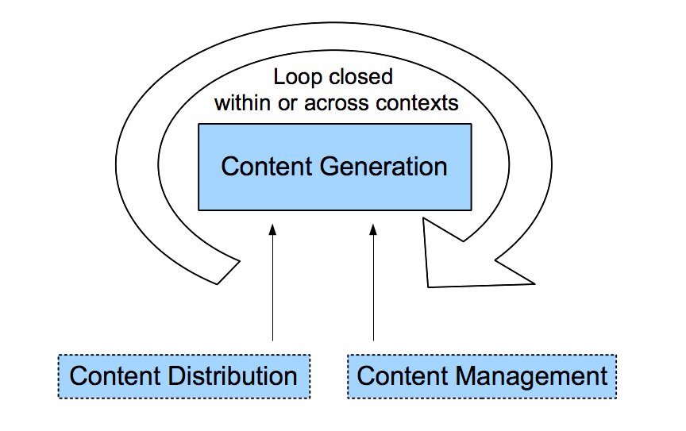
Figure 4: Distribution and management steps as support for LAN closed-loop content generation
A Broader Context
The rapid growth of Information and Communication Technologies (ICTs) has led thoughtful educators to call for the development of new teaching and learning pedagogies that can cross domains. Strategies that have emerged include alternative programme designs and organisational restructuring of administrative policies and procedures (Goode, Willis, Wolf & Harris, 2007). One development to receive attention at UNESCO’s 2009 World Conference on Higher Education was OERs, which were highlighted as one of the “three most significant new dynamics in higher education” (see Daniel & Uvalić-Trumbić, 2010). OERs are simply publicly available resources that have been created specifically for educational purposes. They may be used within existing courses (or as part of Courseware, such as at The Open University in the United Kingdom) or may stand alone as smaller units. Daniel (Ibid.) draws a contrast between the way that academics view the conduct of research and the way that they prepare for teaching. He points out that “When we engage in research we assume that we will build on the research of others”. In contrast, teaching has a tradition of being considered a private activity: “We usually scan current scholarship to ensure that our teaching is up to date. However, apart from recommending textbooks, we rarely make much use of others’ teaching materials, even if we could access them” (Ibid.). OERs are one way in which this situation is changing, driven especially by the growth in use of ICTs (which provide content digitally by default, for instance making adaption to different contexts less time consuming). There are many questions over OERs, including quality assurance issues (heard particularly in the Global North), and accessibility issues in the Global South. For us, however, the key is summarised by Daniel's reference to Ernie Boyer's insistence that “knowing and learning are communal acts”. In our vision for a LAN infrastructure, the communal acts are not limited to the sharing of teaching and learning materials by teachers, educators and academics, but also to the shared creation of narratives by learners. As well as empowering learners, closing the loop using narratives in this way may also offer new understandings by highlighting roadblocks to individual or community learning.

An innovation that influenced us when considering our work in Uganda was the “Hole in the Wall” project inspired by the work of Sugata Mitra (http://www.hole-in-the-wall.com/). However, most Hole in the Wall learning stations require Internet access, and tend to focus on the social learning of computer literacy skills (Dangwal & Kapur 2009), whereas the LAN infrastructure that we envisage focuses on content directly related to a community's learning targets in a context-sensitive way, as well as offering the potential for standalone use without Internet access. An interesting research avenue may be the direct comparison of a Hole in the Wall learning station against a LAN iPad fixed as a portal in a similar way. We are especially interested in the longevity of touch-screens—whether of the iPad or of other mobile devices, such as the touted Indian $35 dollar machine (BBC 2010)—when used in extremely demanding environments that increase greatly the chances of impact or scratching.

One of the curriculum areas that we emphasise in our work is that of science and technology, and we hope to show that even in developed countries a LAN framework has something to offer. For instance, in Japan, the Ministry of Education and Technology has argued that to remain at the leading edge of science and technology, it is necessary to foster young researchers with abundant creativity, who can lead into the future (MEXT 2008 p.181). However, Japan’s science and technology education is falling on global rankings, and MEXT also recognises the dwindling interest and motivation in these areas as well as the antiquated methods and facilities (Ibid., p.190). Our work within Japan is aimed at stimulating and revitalising creativity and interest in science and technology across the education curriculum.

Narratives are widely used in education, often for their power to move and to connect people (see Esquith 2007 for particularly compelling examples). Miller and Goodnow (1991, p.172) describe narratives as social artefacts in which a “narrated self is constructed with and responsive to other people”. This illustrates the power of “stories” to change depending on the context, the audience, and the content: a personal knowledge story aimed for a school-based audience changes when the audience is a wider or more learned community. Digital (as opposed to oral or print-based) stories offer new dynamics by enhancing the power of narrative to transform as they can be easily animated and broadcast, creating a stronger sense of audience and performance (Gadanidis & Hughes, 2010). Knowledge shared by learners can be framed as an “identity text” (Cummins et al, 2005). Simply, stories are often not seen as impersonal documentaries of knowledge (akin to content for learning) but as personal narratives of experience.

Formalising our ideas has led us to discover other approaches, such as the story collection activities of the Maraa organisation in India (http://maraa.in/), which makes videos available to mobile phone users via its Storybank project (Bhat 2008). We also have high hopes for the interactivity of the “Learning through Interactive Voice Educational System” (VOICES) project being developed out of the University of British Colombia (http://lives.cs.ubc.ca). VOICES allows large numbers of users to interact personally with educational content via mobile phones. The African Farm Radio Research Initiative (AFRRI) is a further project that explicitly uses “story” in its description of the most effective way to produce a “Participatory Radio Campaign” (PRC), see (Ward 2010, Pp. 40-45). We believe there is a clear trend of increasing attention towards bottom-up input in the creation of content within learning communities. Within this context, we view our research as providing a timely and transportable facilitation framework capable of meeting the burgeoning needs through the simple expedient of “closing the loop”.

Despite the difficulties associated with “transfer” (see Billing, 2007; Perkins & Salomon, 1992; Tanaka, 2005), we believe that the need for approaches with the potential to work across different domains and cultures is pressing. The scale of the world's educational challenge is well represented by Sir John Daniel (2009): “Access to success in learning does not only mean formal education. Global development depends on the informal and self-directed learning of billions of people” (our emphasis). Conventional thinking about education delivery may not be sufficient if we are to facilitate learning for development, learning for life, and the empowerment of communities. Relatively new educational approaches such as the flipped/mastery model (http://learning4mastery.com/) and the Khan Academy (Khan 2010) both prioritise short videos for education, but are currently dependent on top-down creation of content. We believe that the LAN framework has the bottom-up potential to address the need for “more informal learning that leads directly to improved livelihoods” (Daniel, 2009).

Further Examples
We have already given examples in the Introduction of videos that were developed by Japanese students for schools in Uganda. When trialling these videos in the country, we met representatives of the NGOs “Grassroots Innovations Uganda” (GIU) and the Dutch organisation SNV who were inspired by the narrative content and the simple technology to formally collaborate with us in setting up a workshop where around 30 teachers gathered to make a book of stories that represent Uganda's entire primary school curriculum. We plan to use this book as contextually appropriate background material for students in Japan to create digital narratives of stories that can be used to populate further iPads to be deployed in Uganda. We have further been approached by the local government in the Bukedea region of Uganda, to trial an iPad-based LAN system for primary education in the entire region. (Those wishing more information on this project should refer to Bagenda, Frank, Field & Shiiya (2011), forthcoming accepted paper). It is partly these positive reactions from people on the ground have encouraged us to extend and continue our efforts on the framework.

We are also aware that fulfilling the maximum potential of the LAN framework will depend in part on making the step of content creation as straightforward as possible. Our subjective experience is that our university-level students have been able to use SAM software with minimal instruction. We also wanted to test how educators would react to the software, so at a recent 3-day workshop in Ho Chi Minh City at the regional training centre of the South East Asian Ministers of Education Organisation (SEAMEO), the first and second authors introduced SAM to the participants (teachers from primary to university level), again with minimal directions on specific usage. The basic process of story creation by taking pictures was easily adopted by all groups, for example producing videos with scenes such as those of (Fig. 4). Such experience suggests to us that the process of educating educators to create videos can succeed across cultures. Maybe the primary hurdle to overcome is the simple perception of video as “hard”. At an international education conference we attended towards the end of 2010, a spur-of-the-moment, stop-animation video we created in under two hours to promote conference activities was considered to be of sufficient quality to be shown to all delegates in the main conference hall, and generated significant comment.

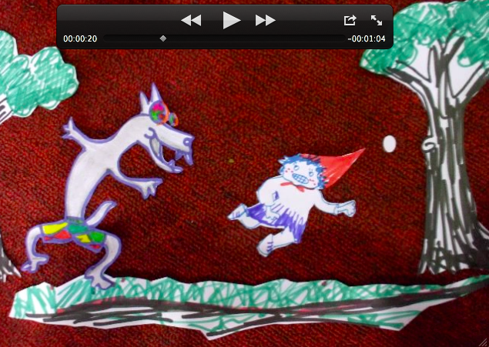
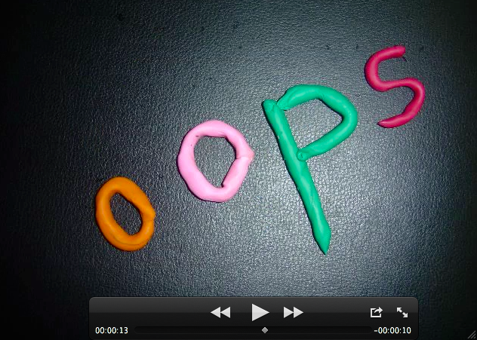
Figure 4: Example screenshots of videos produced by educators in Vietnam

As an example of an application where content creation and distribution occur within a single community, we have also generated videos that explain the basics of Artificial Intelligence to a target audience of Japanese primary age children. To describe such technical content in terms suitable for such young learners was itself a challenge, but the requirement on the creators (again, Japanese university students) to distil topics down to their essence was a useful part of their own learning of the subject matter.

Recently, the first three authors have further investigated how the message of LAN videos can be reinforced by more traditional whole-class teaching methods. For around 60 Japanese elementary age students (from 1st to 6th grade), we used agar plates to collect culture samples from hands before and after washing (students received a 20 minute overview of hygiene issues before washing, to increase the attention they might pay to the task). We then incubated these cultures over three days. Through the direct evidence of seeing cultured mould and bacteria before them, the students could gain concrete experience upon which to then interpret stories about hygiene. We plan to repeat such classes in other local schools in our area, and to investigate how this kind of activity-based teaching can be integrated with other learning through LAN iPad units. We expect this experience to have direct impact on our ability to introduce and support LAN infrastructure in Uganda and in other countries.
Future Directions
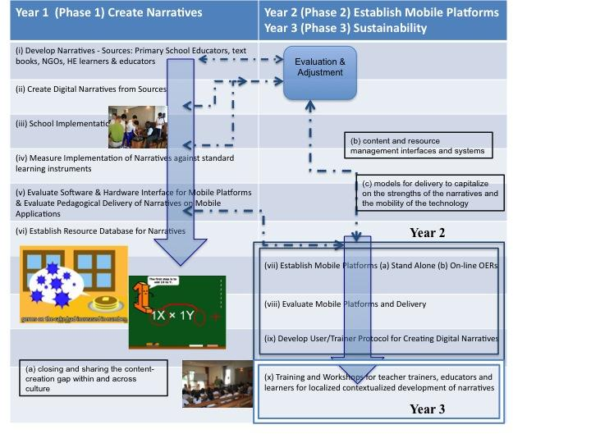
Based on the initial successes discussed above, and the enthusiastic reception of our initial iPad units on the ground, we have initiated a three-year program to develop the LAN framework. A basic summary of this program is shown below (Fig. 5). Year 1 will concentrate on increasing and evaluating content, as well as tackling issues such as evaluating software and hardware interfaces (can we actually achieve our goals by simply loading videos onto iPads?) Once a substantial base of content is in place, we will be able to more meaningfully develop the content management system as well as adjust further the presentation and the maintenance of videos. The goals for the 2nd and 3rd years are to actually deploy significant LAN educational resources, both online and using mobile delivery, and to evaluate their large-scale performance. This will be carried out in parallel with developing protocols for the processes of digital content creation and the practice and the implementation of workshops for teacher trainers & educators and learners, to maximally promote the contextualised generation of LAN stories.

Figure 5: An outline of our LAN framework development program
Conclusions
This paper has described our conceptualisation of a LAN framework for education that can close the loop between teachers and students at different levels of an educational chain, and even cross cultures. We have given details of our initial successes with this idea, and presented a road map for future work and research. Our hope is that we may have encouraged others to think similarly, and to join us in creating a new story to frame thinking and learning within and between cultures.

Although we have not explicitly raised the issue, we believe that especially within the African context our approach can contribute to significant communal learning through the empowerment of parents. This is because the packaging of educational ideas within narratives often demands a certain distillation and contextualisation of the content. Resulting digital videos can therefore be at a level where the educational background of parents is no obstacle to them understanding, auditing, and even reinforcing learning.

A story from one of our Ugandan workshop attendants highlights the importance of local context. A relatively well paid female teacher was teaching a "caring for rabbits" lesson in a war afflicted village, even though she had no real experience with rabbits. According to her textbook (of course, published in a big city), rabbits eat vegetables like carrots. However in her students' war and famine stricken context, even humans cannot afford vegetables. Being contextually sensitive, village rabbits have evolved their dietary habits to accommodate cassava (tapioca), a cheap but relatively hard to digest root tuber. When the teacher (and her out of context textbook) still insisted that rabbits eat vegetables, the students were so angry that the teacher almost got thrown out of her own class.

Families have traditionally played a significant role in the contextualising of the education systems of African countries, with the teacher often also being the parent. We hope that one positive side-effect of our research may be to redress the diminution of the role of Africa's parents in learning, which latterly have too often been stripped down to just the monetary, without even the power to ensure value for their financial outlay.
References
Ayoo, P. O. (2009). Reflections on the Digital Divide and its Implications for the Internationalization of Higher Education in a Developing region: The Case of East Africa, Higher Education Policy, 22/3, p.303-318.
Bagenda D., Frank, I., Field, M.H., & Shiiya, K. (2011). The Road to Better Performance: A Ugandan Experience, International Conference on Learning, 2011 forthcoming accepted paper.
Bhat, R. (2008). Storybank—Using Mobile Phones for Storytelling. http://maraa.in/2008/02/storybank-using-mobile-phones-for-storytelling, Accessed November, 2010.
BBC (2010). India Unveils Prototype For $35 Touch-Screen Computer, BBC News, 13 July 2010, http://www.bbc.co.uk/news/world-south-asia-10740817, Accessed November 2010.
Billing, D. (2007). Teaching for transfer of core/key skills in higher education: Cognitive skills,
Journal of Higher Education, 53, p.483-516.
Cummins, J., Bismillo, V., Chow, P., Cohen, S., Giampopo, F., Leoni, L., Sandhu, P., & Sastri, P. (2005). Affirming Identity in Multilingual Classrooms. Education Leadership, 63(1), p.38-43.
Dangwal R. & Kapur P. (2009). Learning through teaching: Peer-mediated instruction in Minimally Invasive Education, British Journal of Educational Technology Vol 40 No1, p.5-22.
Daniel, J. (2009). Opening Remarks at the ceremony to launch preparations for the 6th Pan-Commonwealth Forum on Open Learning, Chennai, India, 10 October 2009, http://www.col.org/resources/speeches/2009presentation/Pages/2009-10-10.aspx, accessed October 2010.
Daniel, J. & Uvalić-Trumbić, S. (2010). Quality Assurance and Open Educational Resources, Welcome and Introductory Remarks, UNESCO-COL Workshop on Open Education Resources, 3 May 2010, Windhoek, Namibia, http://www.col.org/resources/speeches/2010presentation/Pages/2010-05-03.aspx, Accessed November, 2010.
Esquith, R. (2007). Teach Like Your Hair's on Fire, Penguin Books.
Frank, I. & Field, M.H. (2010). Starting from Scratch: Lifting the Educational Resource Curse, Global Learn 2010 Conference, Penang, Malaysia.
Frank, I. & Field, M.H. (2008). TNT: Technological Thinking, with No Technology, Australian Computers in Education Conference, Canberra, Australia.
Frank, I. & Field, M.H. (2006). Lessons from Indigenous Thought -- Working with "koto" and robotics, Australian Computers in Education Conference, Cairns, Australia.
Goode, S., Willis, R. A., Wolf, J. R. & Harris, A. L. (2007). Enhancing IS education with flexible teaching and learning. Journal of Information Systems Education, 18 (3), p. 297-302.
Gadanidis, G. & Hughes, J. (2010) “Sing me a Good Math Story”: Using Online Music Videos to Share Students’ Classroom Mathematics, Ed-Media, Toronto.
Khan, S. (2010). YouTube U. Beats YouSnooze U.The Chronicle of Higher Education, 31 October 2010, http://chronicle.com/article/YouTube-U-Beats-YouSnooze/125105/, Accessed Nov 2010.
Kim, P. (2010). Paul Kim Homepage Stamford University School of Education, http://www.stanford.edu/~phkim/index.html, accessed October 2010.
MEXT (2008) White Paper on Science and technology Reform, Ch.3.
Miller, P. & Goodnow, J. (1995). Cultural practices: Toward an integration of culture and development. New Directions for Child Development, 67, p.5-16.
Oliver, R. (2002). The Role of ICT in Higher Education for the 21st Century: ICT as a Change Agent for Education, In The Proceedings of the Higher Education for the 21st Century Conference, Miri: Sarawak: Curtin University, http://elrond.scam.ecu.edu.au/oliver
Perkins, D.N. & Salomon, G. (1992). Transfer of Learning, International Encyclopaedia of Education, (2nd Ed). Oxford, England: Pergamon Press.
Tanaka, M. (2005). The Perils of Educational Transfer of Educational Concepts and Practices: A Comparative Study, Oxford: Symposium Books.
Ward, D. (2010). Manual for Participatory Radio Campaigns. http://www.farmradio.org/english/partners/afrri/prc-manual-eng.pdf, Accessed Nov 2010.

